1. App Icon

1.1 Icon image

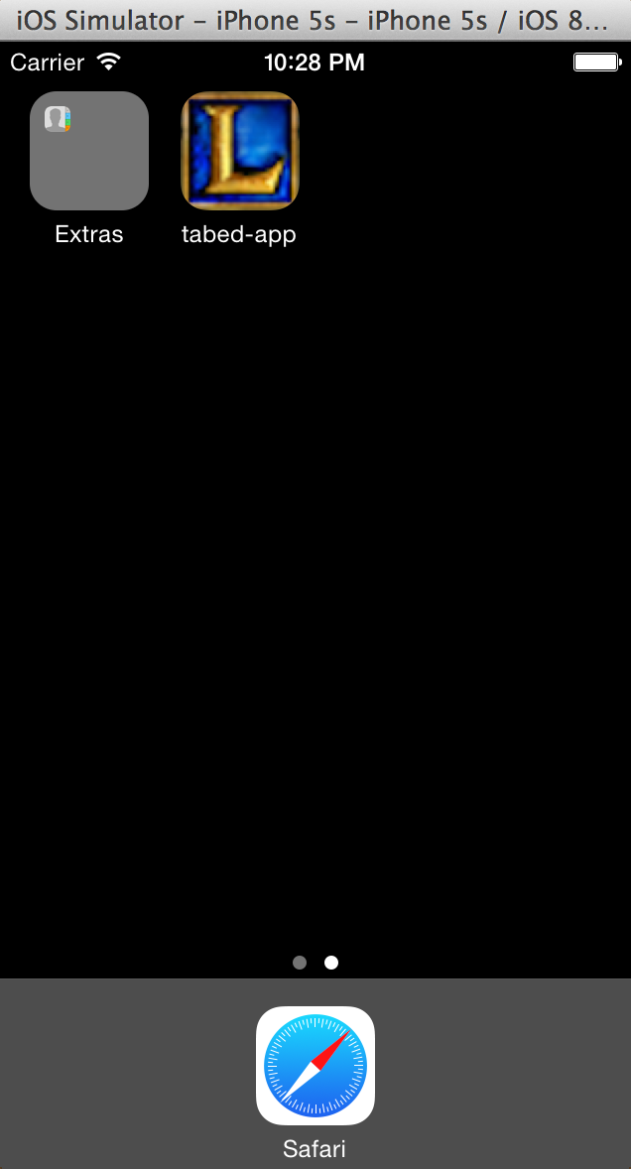

1.2 Icon description

1. First Tab --- Game History Search

2.1 Screen Shot

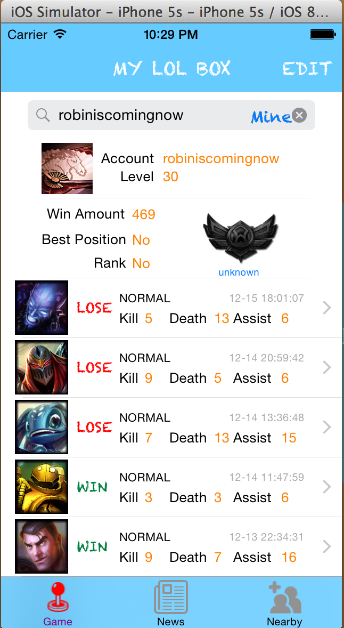 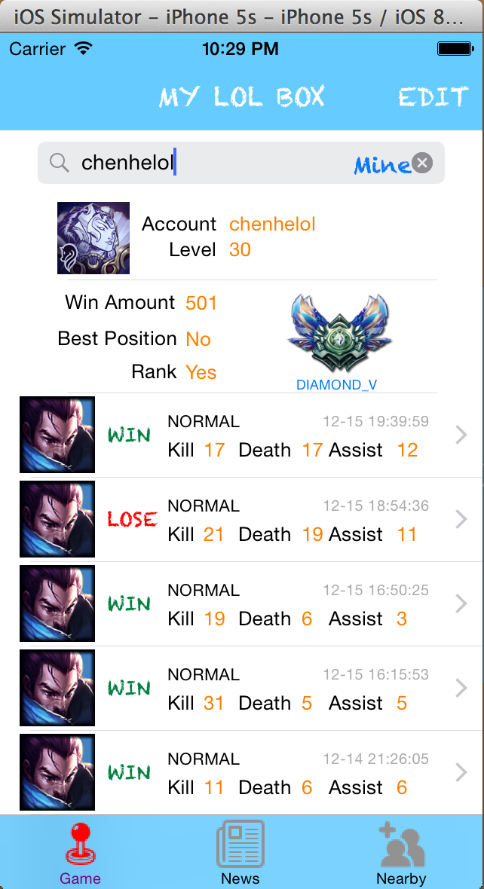

2.2 Class Description

|  |  |
| --- | --- |
| Class Name | Class Functionality |
| FirstViewController | ViewController of this table view  1) Table delegate  2) Table data source  3) Http asynchronous post component  4) Handler of http response |
| SummonerCell | Custom cell for summoner information (Account Name and Level, profile icon) |
| SummonerBasicCell | Custom cell for summoner basic information(Win Amount, Best Position, Rank, Rank profile) |
| SummonerMatchCell | Custom cell for summoner each game(Champion, Result, Game Type, Time, Kill Amount, Death Amount, Assist Amount) |

1. Game Detail

3.1 Screen Shot

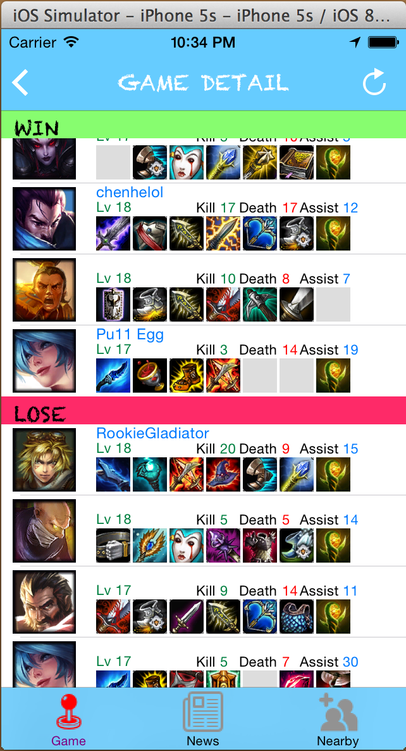

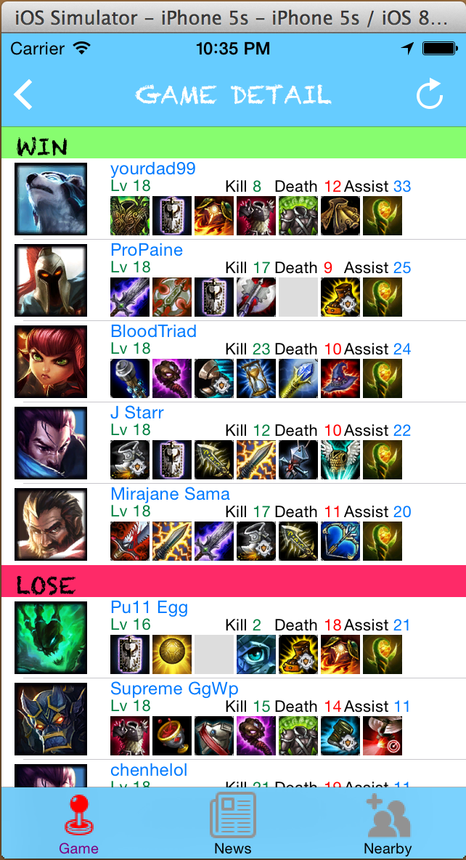

3.2 Class Description

|  |  |
| --- | --- |
| Class Name | Class Description |
| GameDetailController | ViewController of this view  1)Tableview delegate  2)Tableview data source |
| ParticipantCell | Custom cell for participant information(Champion, Champion Level, Items, Summoner Name, Kill Amount, Death Amount, Assist Amount) |

1. My Info Saver

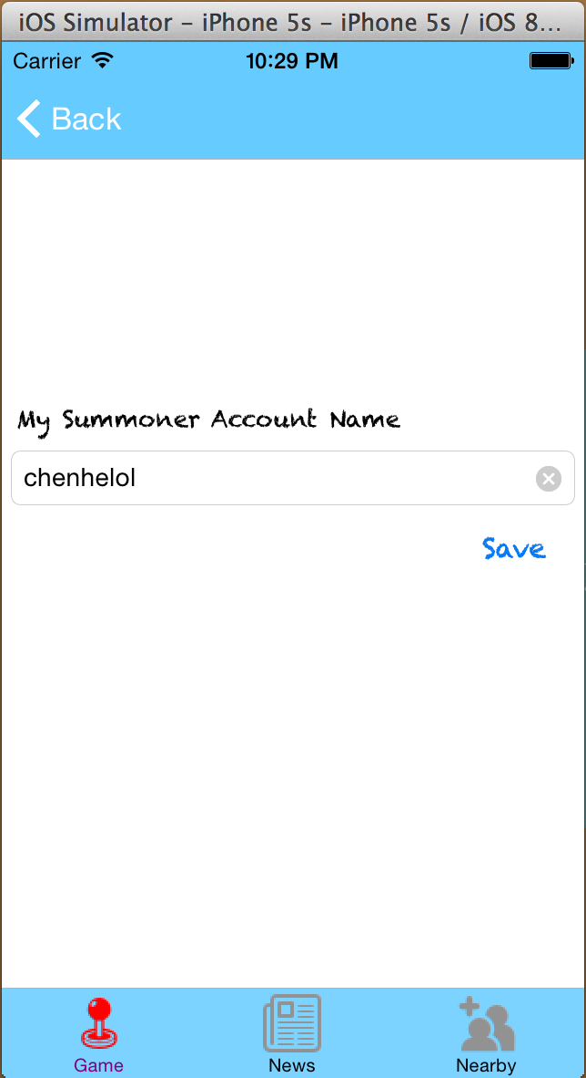

1. Nearby Users

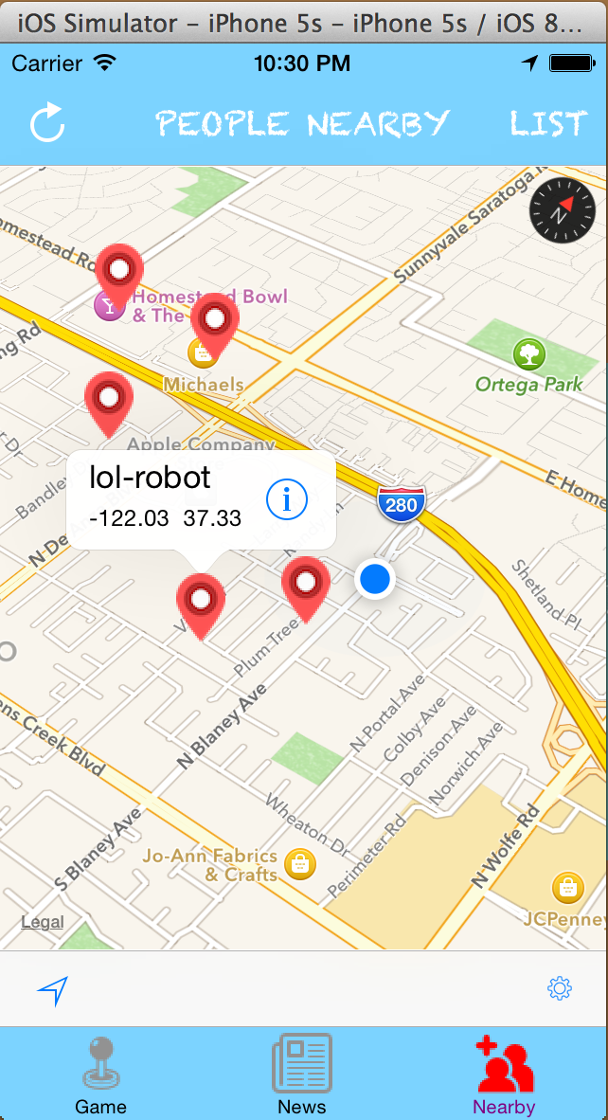

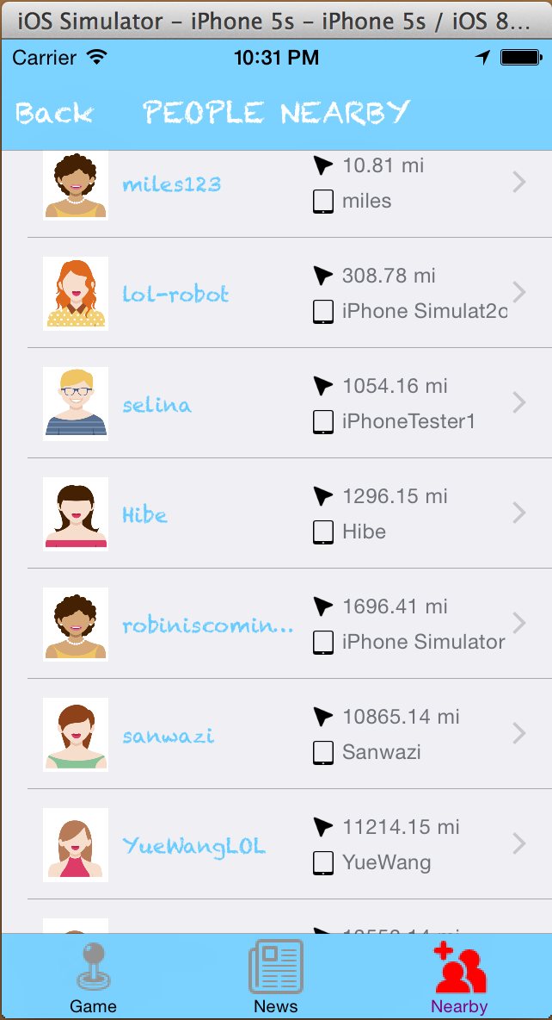

5.2 Class Description

|  |  |
| --- | --- |
| Class Name | Class Description |
| MapViewController | ViewController of mapview |
| NearbyPeopleListController | ViewController of table view |
| NearbyPeopleCell | Custom cell for nearby people(Icon, User Name, Distance, Summoner ID) |

1. LOL News

